A

Create database db_staff;

B

CREATE TABLE TB_DATA_STAFF(

NIK VARCHAR(50) PRIMARY KEY,

Nama VARCHAR(50) NULL,

Alamat VARCHAR(200) NULL,

Handphone VARCHAR(15) NULL

);

C

INSERT INTO TB_DATA_STAFF VALUES('20001','Andi','BANDUNG','123456789','2021-01-31');

D

INSERT INTO TB_DATA_STAFF VALUES('20002','Bulan','MEDAN','234567891',null);

INSERT INTO TB_DATA_STAFF VALUES('20003','Charles','SIDOARJO','345678912',null);

INSERT INTO TB_DATA_STAFF VALUES('20011','Dilan','BANDUNG','456789123',null);

INSERT INTO TB_DATA_STAFF VALUES('20005','Ebi','SURABAYA','567891234',null);

INSERT INTO TB_DATA_STAFF VALUES('20006','Fanni','PROBOLINGGO',null,null);

INSERT INTO TB_DATA_STAFF VALUES('20007','Gilang','SURABAYA','789123456','2021-05-31');

INSERT INTO TB_DATA_STAFF VALUES('20013','Hari','BALI','891234567',null);

INSERT INTO TB_DATA_STAFF VALUES('20012','Ian','SOLO','912345678','2021-07-31');

INSERT INTO TB_DATA_STAFF VALUES('20010','John','SURABAYA','1123456789',null);

E

ALTER TABLE TB_DATA_STAFF ADD Joindate date;

F

select TOP (2) * from TB_DATA_STAFF;

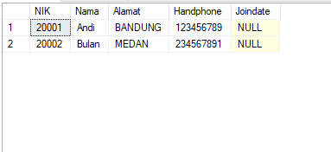

G

select TOP (3) * from TB_DATA_STAFF;

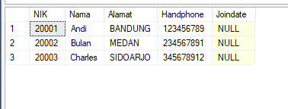

H

CREATE TABLE TB_DATA_STAFF_OUTSOURCE(

NIK VARCHAR(50) PRIMARY KEY,

Nama VARCHAR(50) NULL,

Alamat VARCHAR(200) NULL,

Handphone VARCHAR(15) NULL,

Joindate date NULL

);

I

INSERT INTO TB_DATA_STAFF_OUTSOURCE VALUES

('20001','Andi','SURABAYA','123456789','2021-01-31'),

('20002','Bulan','SURABAYA','234567891','2021-02-15'),

('20003','Charles','SURABAYA','345678912','2021-09-30'),

('20004','Dilan','BANDUNG','456789123','2021-10-15'),

('20005','Ebi','MEDAN','567891234','2021-03-31'),

('20006','Fanni','BALI','678912345','2021-04-15'),

('20007','Gilang','SIDOARJO','789123456','2021-05-31'),

('20008','Hari','PROBOLINGGO','891234567','2021-06-15'),

('20009','Ian','JAKARTA','912345678','2021-07-31'),

('20010','John','SURABAYA','1123456789','2021-08-15');

J

SELECT * FROM TB_DATA_STAFF AS staff JOIN TB_DATA_STAFF_OUTSOURCE AS os ON os.Joindate=staff.Joindate;

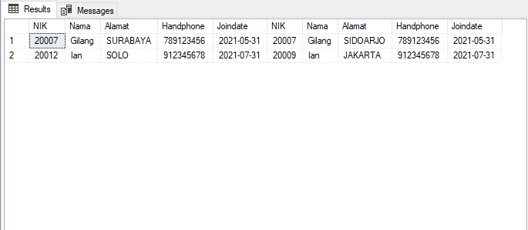

K

SELECT * FROM TB_DATA_STAFF AS staff right JOIN TB_DATA_STAFF_OUTSOURCE AS os ON os.NIK=staff.NIK;

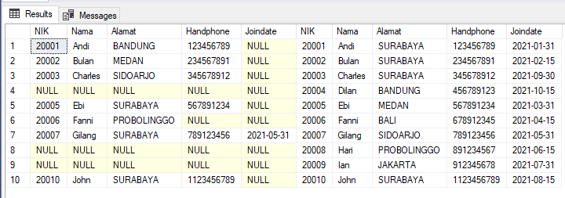

L

SELECT * FROM TB_DATA_STAFF AS staff LEFT JOIN TB_DATA_STAFF_OUTSOURCE AS os ON os.Nama!=staff.Nama;

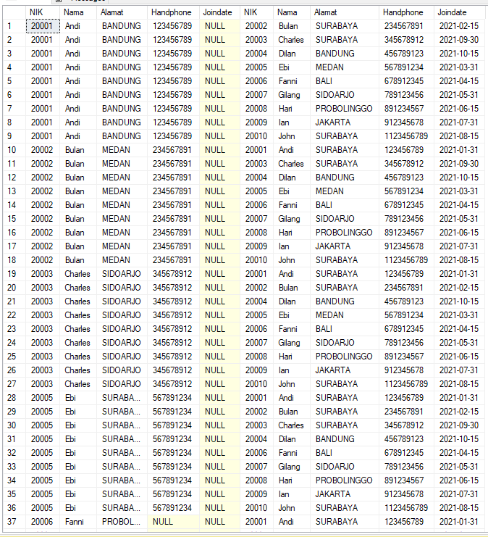

--M

SELECT * FROM TB_DATA_STAFF UNION SELECT * FROM TB_DATA_STAFF_OUTSOURCE;

